**CYBER SECURITY PROJECT**



Topic : IP-address Tracker

Group Members :

20BCS112 – K. Vamshi Krishna

20BCS130 – M. Pavan Kumar

20BCS244 – VVSD. Charan

**Introduction to IP-address tracker**

IP-Tracer is a tool designed for Linux systems to track IP addresses. It utilizes ip-api for retrieving detailed information about a given IP address. This tool enables users to trace and gather essential data related to an IP address effortlessly, enhancing network monitoring and security measures.

**Getting started**

Step 1 : Installing git using “apt install git -y” command, which installs the Git package without requiring manual confirmation at each step.

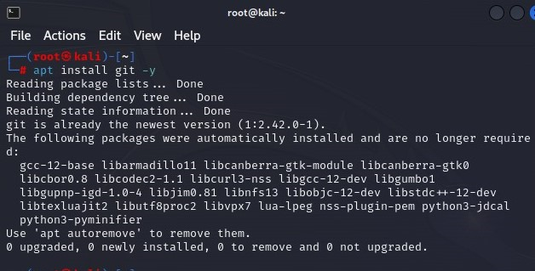

Step 2 : Using command “git clone <https://github.com/pavankumar130/IP-Tracer>”. This allows to obtain a copy of the project's source code and related files for inspection, modification, or use.

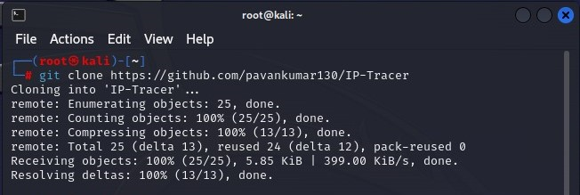

Step 3 : The command "chmod +x install" is used to add execute permissions to a file.

Step 4 : Using command “./install” to install all packages.

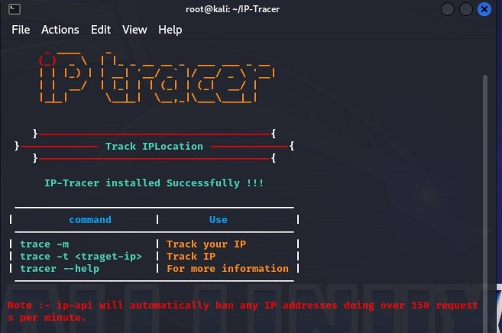

**Finding location and relevant information by tracking IP address**

An IP address can be tracked using command “ip-tracer -t target-ip”. This command instructs IP-Tracer to trace the specified target IP address. The tool would then use the provided IP address to retrieve information about its location and other relevant details using the ip-api service.

1)Tracking IP address 14.139.241.220 using command “ip-tracer -t 14.139.241.220”

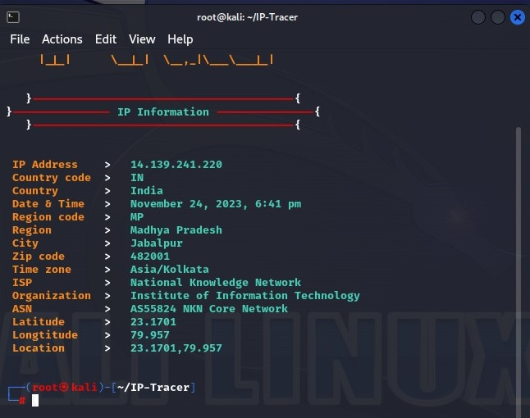

2)Tracking IP address 192.0.1.0 using command “ip-tracer -t 192.0.1.0”.

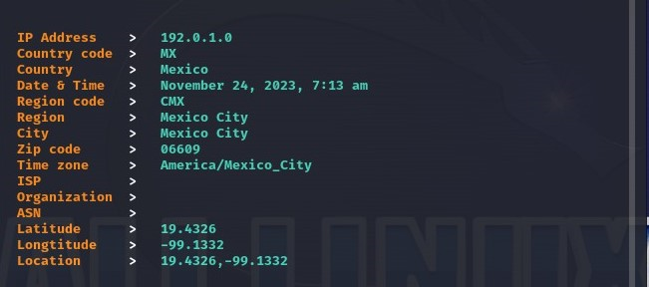

**Functionalities of the project**

* Public IP addresses are typically trackable as they are registered and associated with specific geographic locations.
* Static IP addresses remain constant and are easier to trace accurately.

**Limitations of IP-address Tracker**

* Private IP addresses, used within local networks (e.g., 192.168.x.x or 10.x.x.x), are not directly traceable over the internet. Additionally, reserved IP ranges and multicast addresses may not be trackable.
* Dynamic IP addresses assigned by ISPs may change periodically, making tracking less reliable over time.
* Users employing virtual private networks (VPNs) or proxy servers often mask their real IP addresses, making accurate tracking challenging.
* Firewalls and security configurations can block or limit the effectiveness of IP tracking tools.
* If the IP tracking tool relies on a geolocation database that is incomplete or outdated, certain IP addresses may not be accurately traced.
* Some IP addresses may not be tracked due to privacy regulations or user preferences.

**How to avoid tracking our IP address?**

* Use a VPN (Virtual Private Network)

A VPN encrypts internet connection and routes traffic through a server in a different location, masking real IP address. It adds an extra layer of privacy and security.

* Using a proxy Server

Similar to a VPN, a proxy server can act as an intermediary between your device and the internet, hiding the IP address. However, it may not provide the same level of encryption as a VPN.

* Using Tor browser

The Tor network routes internet traffic through a series of volunteer-operated servers, making it more difficult to trace IP address. The Tor Browser is designed to enhance privacy and anonymity.

* Dynamic IP addresses

If ISP (Internet Service Provider) provides a dynamic IP address, it changes periodically. While this won't make IP completely untraceable, it adds an extra layer of complexity for those attempting to track the IP.

* Using HTTPS

When browsing websites, ensure that the connection is secure by using websites that support HTTPS. This encrypts the data exchanged between user’s device and the website.

* Disabling Geolocation Services

Many devices and browsers have geolocation services that can track user’s physical location. Disabling these services when not needed will help users to hide from IP-tracking.

* Firewall Settings

Configuring firewall to block incoming requests and limit the information that can be accessed from the outside.